CYBR3030 – Cryptography Case Study Report
Prepared for: Bruce Wayne, Edmonton Comics

Table of Contents
1. Summary
2. Network Diagram
3. Gap Analysis & Risks
4. Cryptographic Solutions & Recommendations
5. References

Summary
This report analyzes the current security posture of Edmonton Comics' network and provides recommendations for improving cryptographic protections. It evaluates the risks associated with plaintext credentials, self-signed certificates, partner access, and data security. The report also identifies cryptographic methods to protect data in transit and at rest, ensuring secure collaboration with authorized partners.

Network Diagram
The following diagram represents the current network environment as described in the scenario:
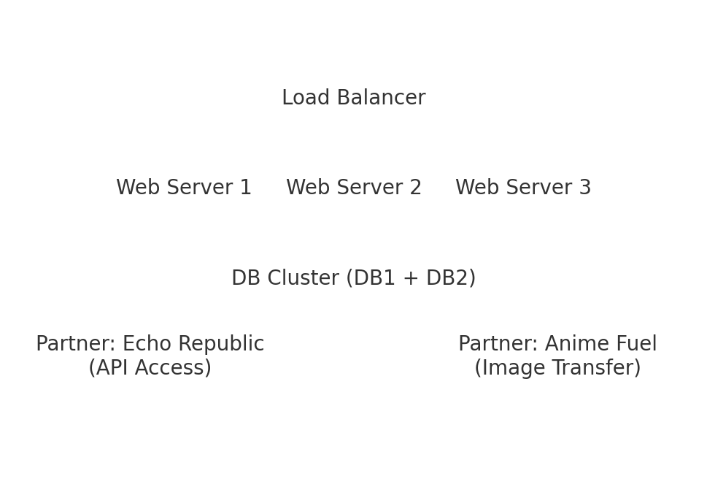

Gap Analysis and Risks
1. Plaintext storage of usernames and passwords creates a major risk of credential compromise.
2. Use of a self-signed certificate increases vulnerability to man-in-the-middle attacks.
3. Partners access sensitive data without enforced encryption standards.
4. No mention of database encryption, increasing risk of data exposure.
5. Lack of strong authentication mechanisms for external partners.

Cryptographic Solutions & Recommendations
• Implement TLS with certificates issued by a trusted Certificate Authority (CA).
• Hash all stored passwords using bcrypt, PBKDF2, or Argon2.
• Use AES-256 for encrypting stored data.
• Enforce end‑to‑end encryption for API partner communications.
• Replace self‑signed certificates with CA‑signed certificates to ensure authenticity.

References
References available upon request or to be completed by student.

